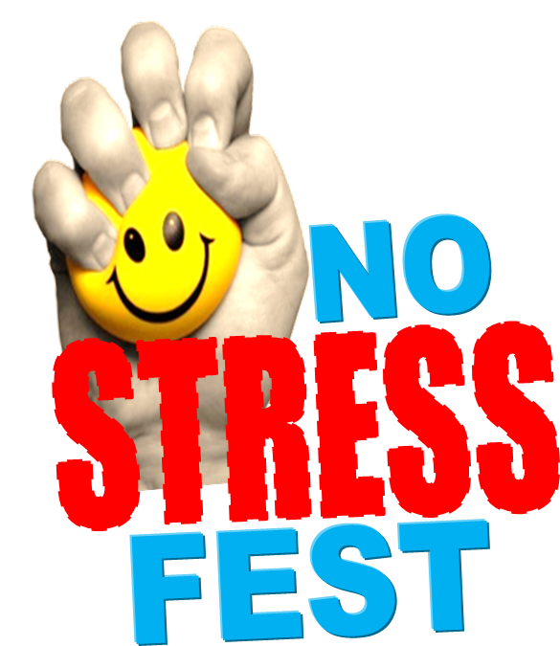
We want your Feedback…

- What did you like best about the event?

- What did you like least? What did not work well? What would you change about the event?

- Suggestions for future activities or events…

- Are you more aware of the available Mental Health & Addiction Services than before?
Yes No

- Did this event help you think about how you currently manage stress?
Yes No

- Did this event help you think about new ways to manage stress?
Yes No

- Other Comments…

We want your Feedback…

- What did you like best about the event?

- What did you like least? What did not work well? What would you change about the event?

- Suggestions for future activities or events…

- Are you more aware of the available Mental Health & Addiction Services than before?
Yes No

- Did this event help you think about how you currently manage stress?
Yes No

- Did this event help you think about new ways to manage stress?
Yes No

- Other Comments…

